

Student Name: KABURU EVANS MUTHOMI
Admission Number: BSCCS/2024/62210
Course/Class: Bachelors of Science in Computer Science
Unit Code: BIT4138
Unit Name: Advanced Cryptography
Lecturer Name: Michael Nyoro
Semester/Academic Year: May/August 2026

GitHub Repository Link:
https://github.com/mthomikaburu
Contents
Week 4 3
Block Cipher Design and AES 3
Fig 1: AES Encryption Script 3
Fig 2: Key Generation Process 4
Fig 3: File Encryption Demonstration 5
Fig 4: Decryption Results 6
Fig 5: AES Performance Testing 7
Student Reflection 7

Week 4

Block Cipher Design and AES
Advanced Encryption Standard (AES) and Block Cipher Operations

Fig 1: AES Encryption Script
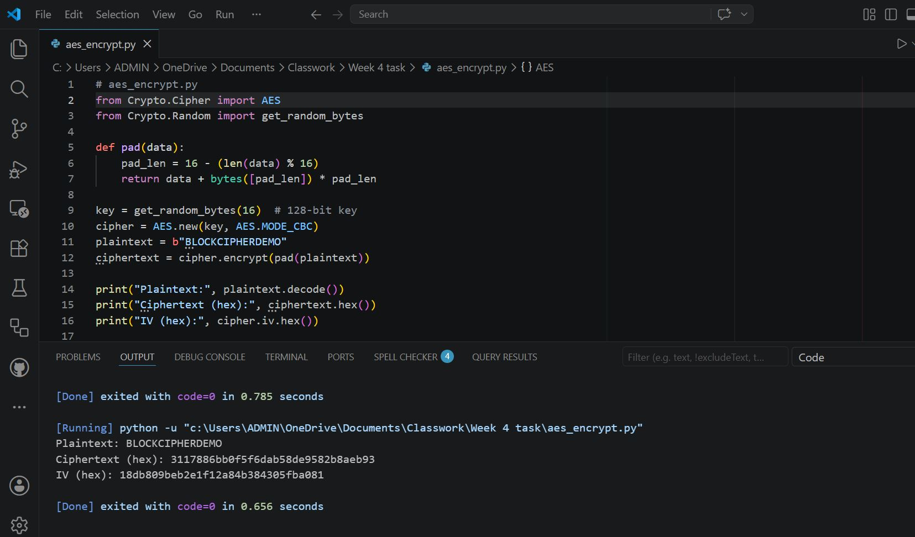

Fig 2: Key Generation Process

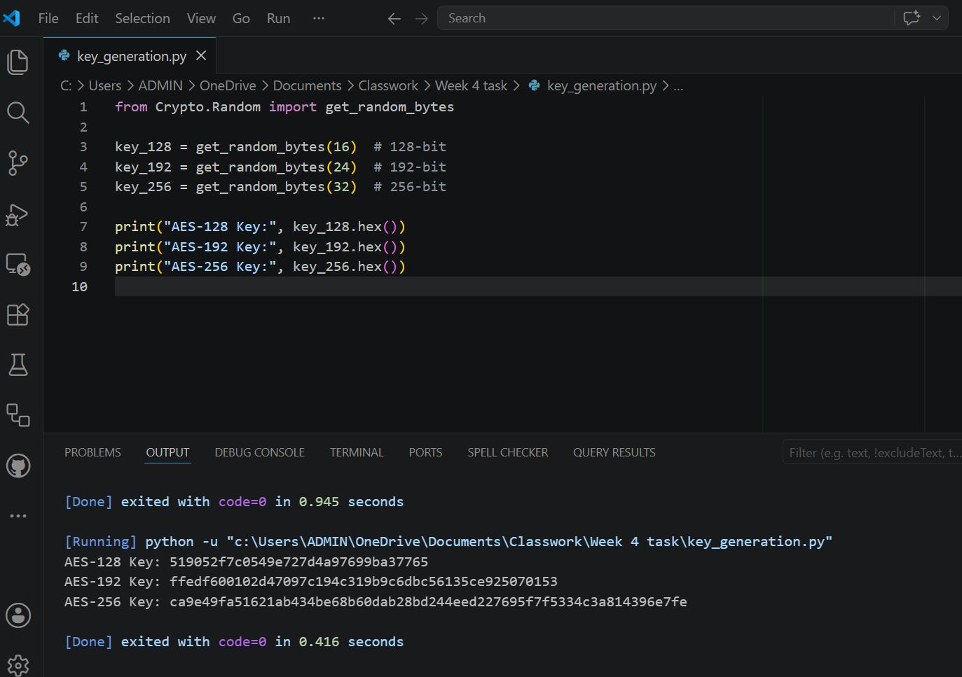

Fig 3: File Encryption Demonstration

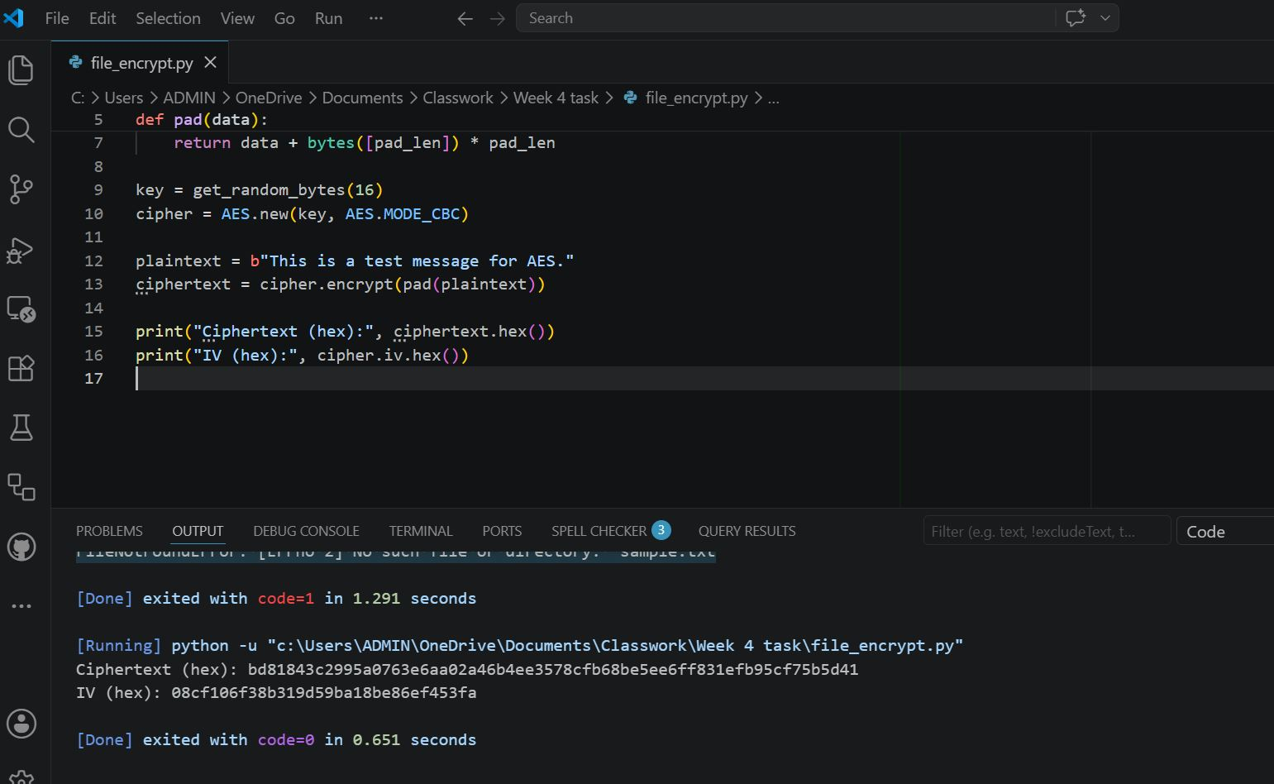

Fig 4: Decryption Results

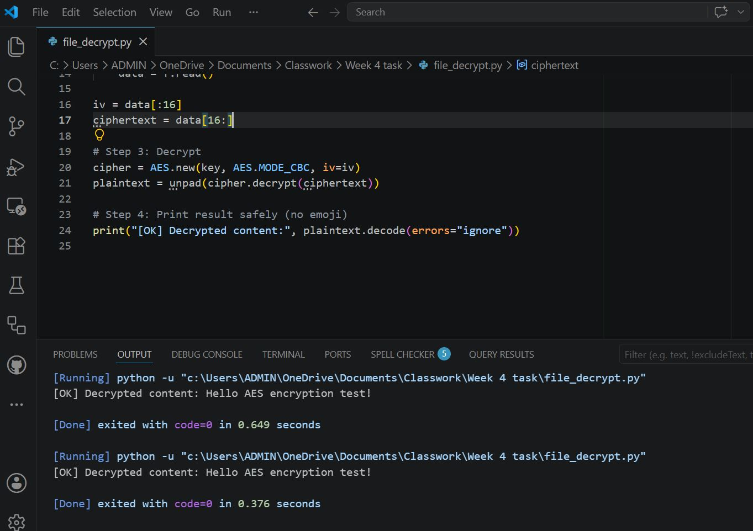

Fig 5: AES Performance Testing

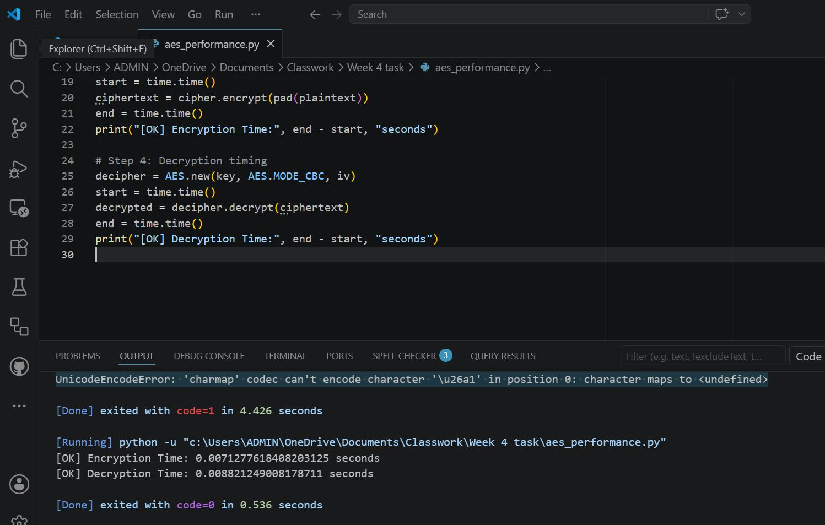

Student Reflection
AES encryption workflow involved key generation, CBC mode, padding, and IV handling. Secure key storage was critical for successful decryption. Screenshots confirmed encrypted and decrypted outputs. Main challenge was ensuring .bin files were correctly created before decryption, highlighting the importance of proper implementation steps.

